Guess The Game
Question 1:

Graffiti
Tracks

Coins

Hoverboard

Inspector
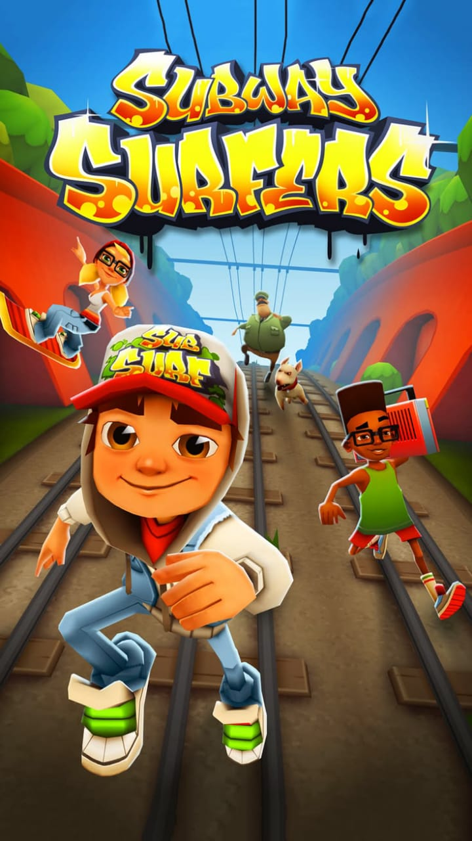

Question 2 :
Island
Parachute

Weapons

Zone

Booyah

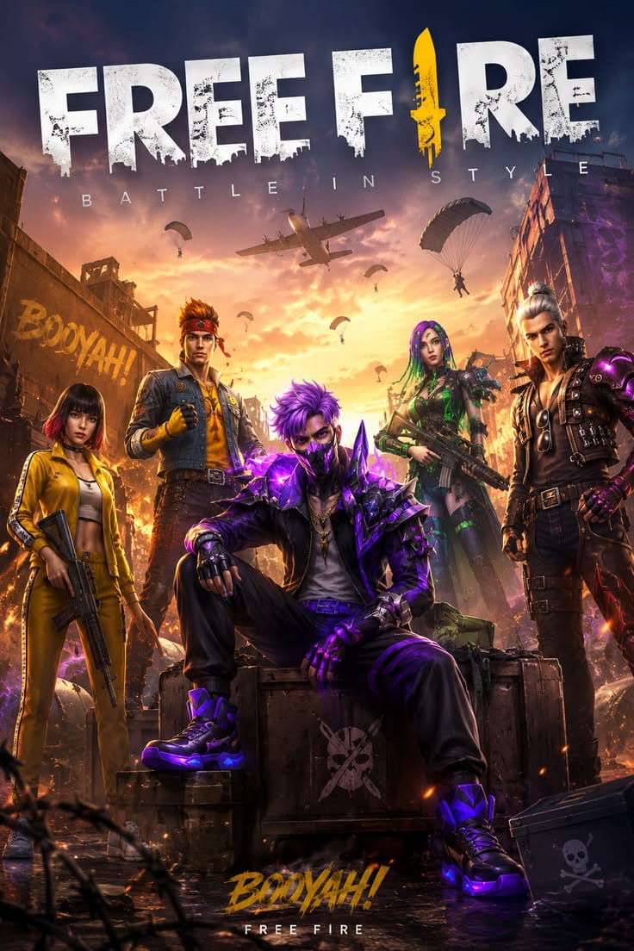
Question 3 :

Colours Numbers

Reverse

Draw Four

Shout

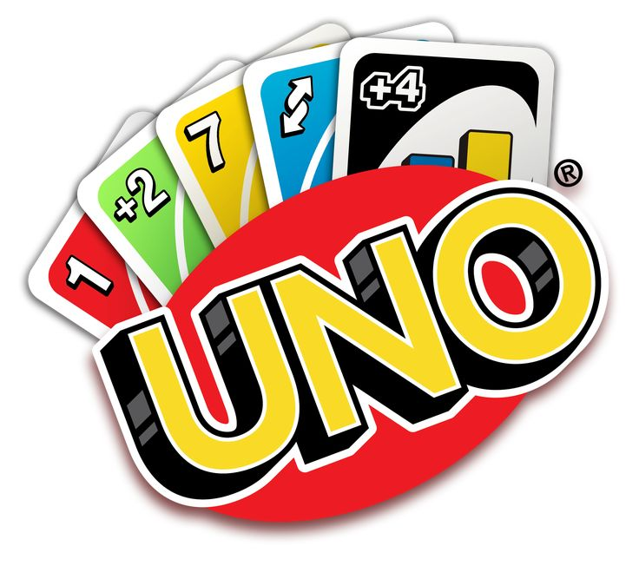

Question 4 :

Spaceship
Crewmates

Vent

Meeting

Impostor
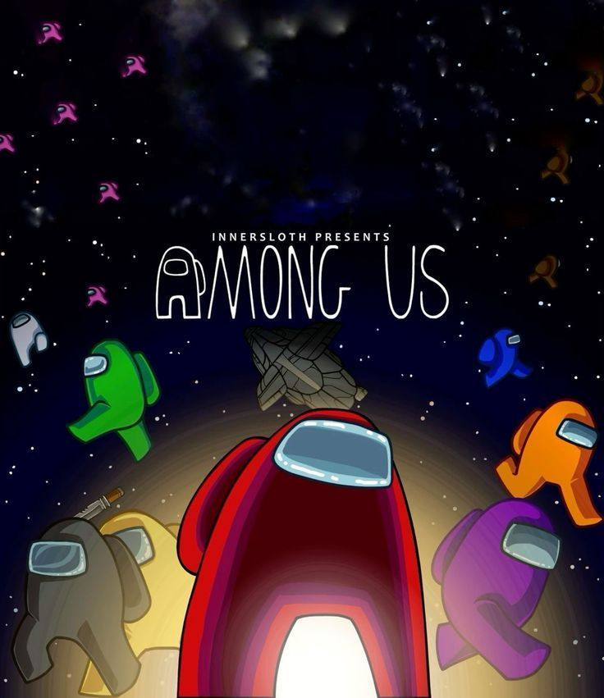

Question 5 :
Village
Elixir

Barbarian

Townhall

War

